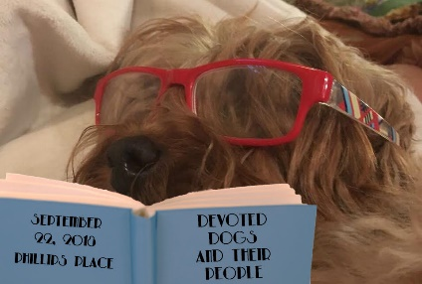 | 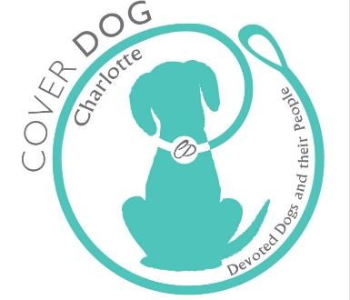 | 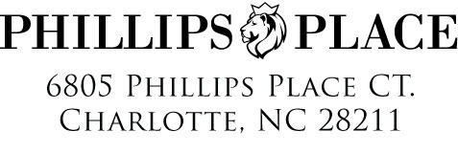
Announces our NEW
2018 COVER DOG Search Charlotte

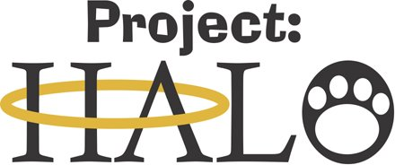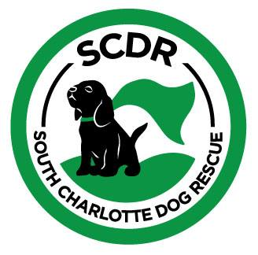

Name:
Company:

Dear:

Cover Dog returns for the 2018 COVER DOG Charlotte Contest. We invite you to be our partner in celebrating the love of dogs while making a difference in the future of our homeless pet population. This years event will be held Saturday, September 22,2018 from 3:00-6:00 at Phillips Place (stage area) in South Park ,6700 Phillips Place Court , Charlotte,NC 28210

The Project Halo and South Charlotte Dog Rescue serves the animals and people of Charlotte, NC and the surrounding counties. We are not a government-run organization. The Project Halo and South Charlotte Dog Rescue is a private 501(c)(3) non-profit. All donations are deductible to the fullest extent of the law.The Project Halo and South Charlotte Dog Rescue does not own or operate a shelter facility. Volunteers foster all animals in their homes until adopted.

OUR MISSION
Many of our animals come from high-kill shelters and other rescue situations. We find that fostering gives us the opportunity to assess the animal's personality and needs. This allows us to best match them with the right adoptive family. Also, we are able to provide all care and medical needs for our animals. It enables the animal to develop a happy frame of mind before adoption. We have many wonderful animals looking for a forever home.
To improve the quality of life of homeless animals through veterinary care, foster care, humane education, and spay/neuter programs. https://www.projecthalo.net

The winner of 2018 Cover Dog will be featured on the cover of Devoted Dogs and their People“

Thank you for considering this opportunity for your company to sponsor the 2018 COVER DOG Search. Your sponsorship will make a difference in the lives of pets needing forever homes in the Charlotte area.

For additional information, please visit the COVER DOG Search website at http://www.deborahbellandcompany.com/coverdogcharlotte or if you have any questions, contact Deborah directly at 704-560-2304 or coverdogwinner@gmail.com.

Sincerely,
Deborah Bell Founder/Producer / Gina LaRosa Associate Producer / Bryan Paschal Marketing Associate

2018 COVER DOG Search Charlotte - Sponsorship Levels

Phillips Place - $5,000
- Exclusive signature banner with company name/logo (no competing business of same nature)
- Logo on all promotional marketing materials
- Reserved “Front-Of-Stage” seating ( seats)
- Company recognition during event by Emcee
- Presenter Cover Dog Charlotte
- 3 dog entries to competition
- Custom fresh floral designs by Deborah Bell and Company ,December 2017 and March 2018
- 3 books DevotedDogs and their People”
- 2 Dog stories in the book

South Park - $3,000
- Group signature banner with company name/logo
- Logo on all promotional marketing materials (vender and entry form)
- Reserved “Front-Of-Stage” seating (2 seats)
- Company recognition during event by Emcee.
- Presenter of 1st runner up
2 dog entries to competition
- Custom fresh floral design by Deborah Bell and Company , October 2018
- 2 books Devoted Dogs and their People”
- Dog story in book

Myers Park - $2,000
- Group signature banner with company name/logo
- Reserved “Front-Of-Stage” seating (2 seats)
- Company recognition during event by Emcee
- Presenter of 2nd and 3rd runner ups
- 1 book “ Devoted Dogs and their People”

Plaza Midwood- $1,500
- Name of company posted at event
- Presenter of 4th runner ups
- Reserved “Front-Of-Stage” seating (1 seat)
- 1 dog entry to competition
- 1 book
Noda - $500
- Name of company posted at event
- Presenter of ribbons for top 10/ along with little ambassdor

OUR MISSION

ERADICATING animal abuse and homeless pets by sharing our mission and fundraising for surrounding counties t
throughout the North Carolina region.
.

